VALLAL
S.I. ALAGARSAMY CHETTIAR
HIGHER SECONDARY SCHOOL
2 & 3, Adam Sahib Street, Royapuram, Chennai - 13.
9, Somu Chetty Street, Royapuram, Chennai -13.

044-25956745
044-25981350

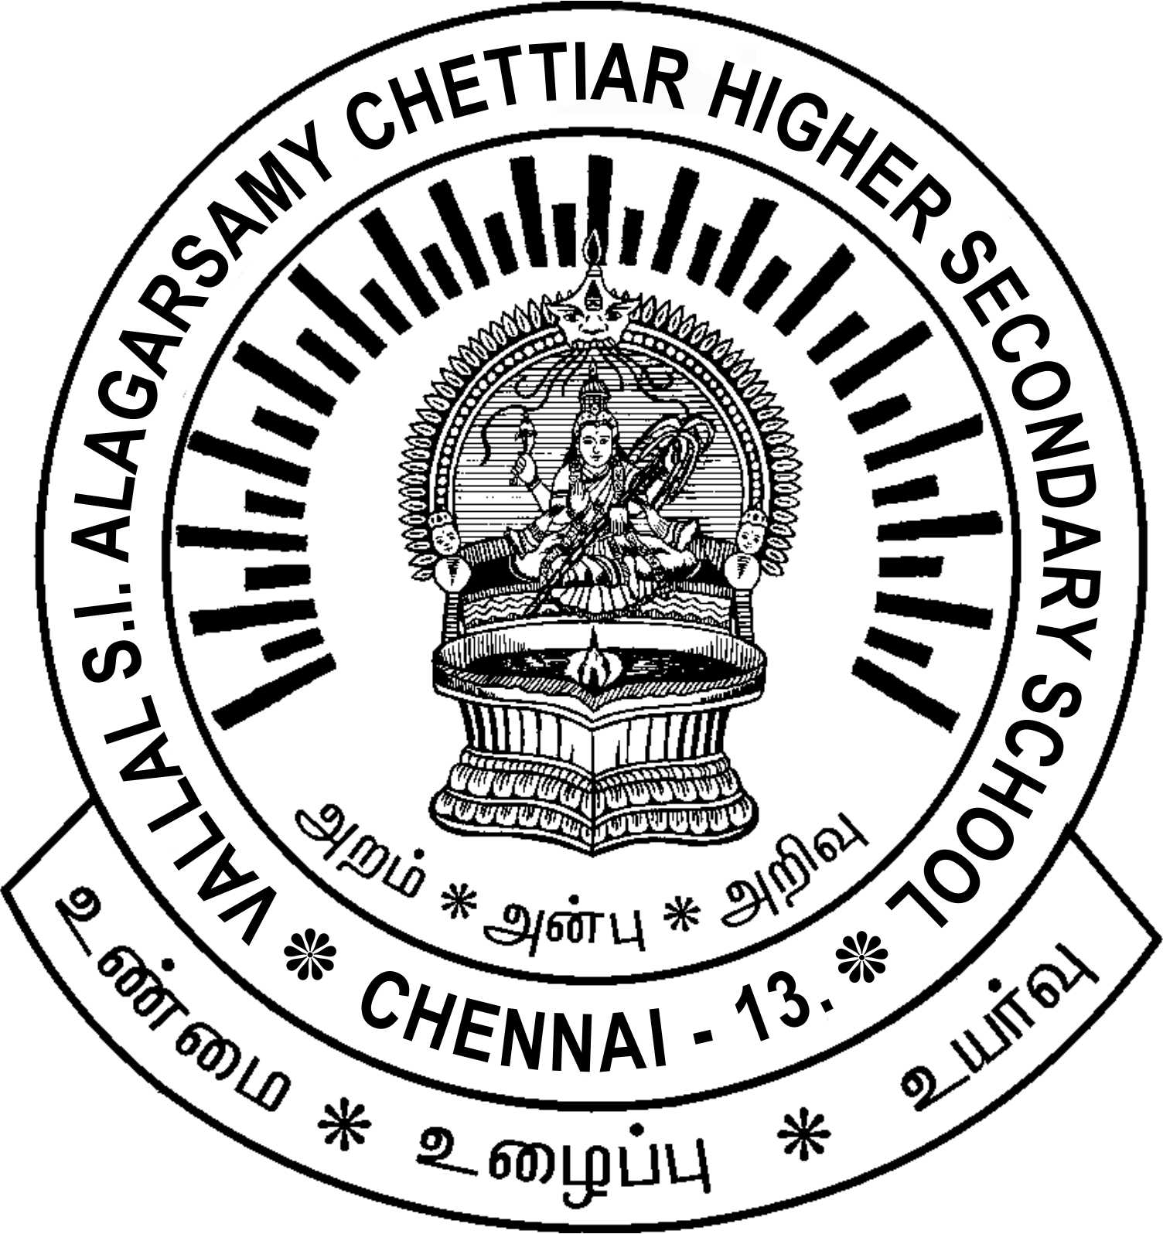

PROSPECTUS

For HIGHER SECONDARY COURSE

Part I Languages - Tamil

Part II English

Part III Any one of the combinations of the subjects

GROUP GENERAL EDUCATION

❖ GROUP I A Physics, Chemistry, Biology, Mathematics
(Tamil & English Medium)

❖ GROUP I B Physics, Chemistry, Computer Science, Mathematics
(English Medium)

❖ GROUP II A History, Economics, Commerce, Accountancy
(Tamil Medium)

❖ GROUP II B Economics, Commerce, Accountancy, Business Maths & Statistics
(Tamil Medium)

❖ GROUP II C Computer Applications, Economics, Commerce, Accountancy
(English Medium)

VOCATIONAL EDUCATION

❖ GROUP III Computer Application, Commerce, Accountancy, Auditing Practical
(English Medium)

